8. FCFS

processes = []

n = int(input("Enter Number of Processes: "))
for i in range(n):
data = input(f"Enter AT and BT (space separated): ")
at, bt = map(int, data.split())
processes.append({"pid": i + 1, "arrival_time": at, "burst_time": bt})

queue = []
time = 0
completed = 0
gantt_chart = []
remaining_processes = processes.copy()
current_process = None
start_time = 0

while completed < n:
for process in list(remaining_processes):
if process["arrival_time"] <= time:
queue.append(process)
remaining_processes.remove(process)

if current_process is None and queue:
current_process = queue.pop(0)
start_time = time
current_process["remaining_time"] = current_process["burst_time"]

if current_process:
current_process["remaining_time"] -= 1

if current_process["remaining_time"] == 0:
end_time = time + 1
gantt_chart.append((current_process["pid"], start_time, end_time))
current_process = None
completed += 1

time += 1

print("\nGantt Chart:")
for pid, start, end in gantt_chart:
print(f"| P{pid} ({start} - {end}) ", end="")
print("|")

process_stats = {}
for pid, start, end in gantt_chart:
process_stats[pid] = {"completion_time": end}

for process in processes:
pid = process["pid"]
at = process["arrival_time"]
bt = process["burst_time"]
ct = process_stats[pid]["completion_time"]

tat = ct - at
wt = tat - bt

process_stats[pid].update({
"arrival_time": at,
"burst_time": bt,
"turn_around_time": tat,
"waiting_time": wt
})

print("\nProcess Stats:")
print("PID\tAT\tBT\tCT\tTAT\tWT")
total_tat = 0
total_wt = 0
for pid in sorted(process_stats.keys()):
stat = process_stats[pid]
at = stat["arrival_time"]
bt = stat["burst_time"]
ct = stat["completion_time"]
tat = stat["turn_around_time"]
wt = stat["waiting_time"]
total_tat += tat
total_wt += wt
print(f"P{pid}\t{at}\t{bt}\t{ct}\t{tat}\t{wt}")

print(f"\nAverage Turn Around Time: {total_tat/n:.2f}")
print(f"Average Waiting Time: {total_wt/n:.2f}")

Output
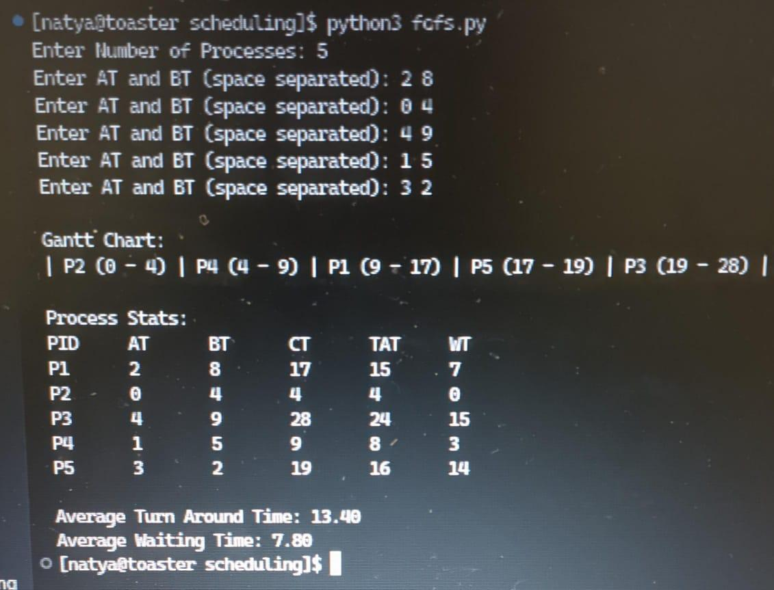

9. SJF
processes = []

n = int(input("Enter Number of Processes: "))
for i in range(n):
data = input(f"Enter AT, BT and Priority (space separated): ")
at, bt, priority = map(int, data.split())
processes.append({"pid": i + 1, "arrival_time": at, "burst_time": bt, "priority": priority})

queue = []
time = 0
completed = 0
gantt_chart = []
remaining_processes = processes.copy()
current_process = None
start_time = 0

while completed < n:
for process in list(remaining_processes):
if process["arrival_time"] <= time:
queue.append(process)
remaining_processes.remove(process)

if current_process is None and queue:
queue.sort(key=lambda x: x["priority"])
current_process = queue.pop(0)
start_time = time
current_process["remaining_time"] = current_process["burst_time"]

if current_process:
current_process["remaining_time"] -= 1

if current_process["remaining_time"] == 0:
end_time = time + 1
gantt_chart.append((current_process["pid"], start_time, end_time))
current_process = None
completed += 1

time += 1

print("\nGantt Chart:")
for pid, start, end in gantt_chart:
print(f"| P{pid} ({start} - {end}) ", end="")
print("|")

process_stats = {}
for pid, start, end in gantt_chart:
process_stats[pid] = {"completion_time": end}

for process in processes:
pid = process["pid"]
at = process["arrival_time"]
bt = process["burst_time"]
priority = process["priority"]
ct = process_stats[pid]["completion_time"]

tat = ct - at
wt = tat - bt

process_stats[pid].update({
"arrival_time": at,
"burst_time": bt,
"priority": priority,
"turn_around_time": tat,
"waiting_time": wt
})

print("\nProcess Stats:")
print("PID\tAT\tBT\tPriority\tCT\tTAT\tWT")
total_tat = 0
total_wt = 0
for pid in sorted(process_stats.keys()):
stat = process_stats[pid]
at = stat["arrival_time"]
bt = stat["burst_time"]
priority = stat["priority"]
ct = stat["completion_time"]
tat = stat["turn_around_time"]
wt = stat["waiting_time"]
total_tat += tat
total_wt += wt
print(f"P{pid}\t{at}\t{bt}\t{priority}\t\t{ct}\t{tat}\t{wt}")

print(f"\nAverage Turn Around Time: {total_tat/n:.2f}")
print(f"Average Waiting Time: {total_wt/n:.2f}")

Output
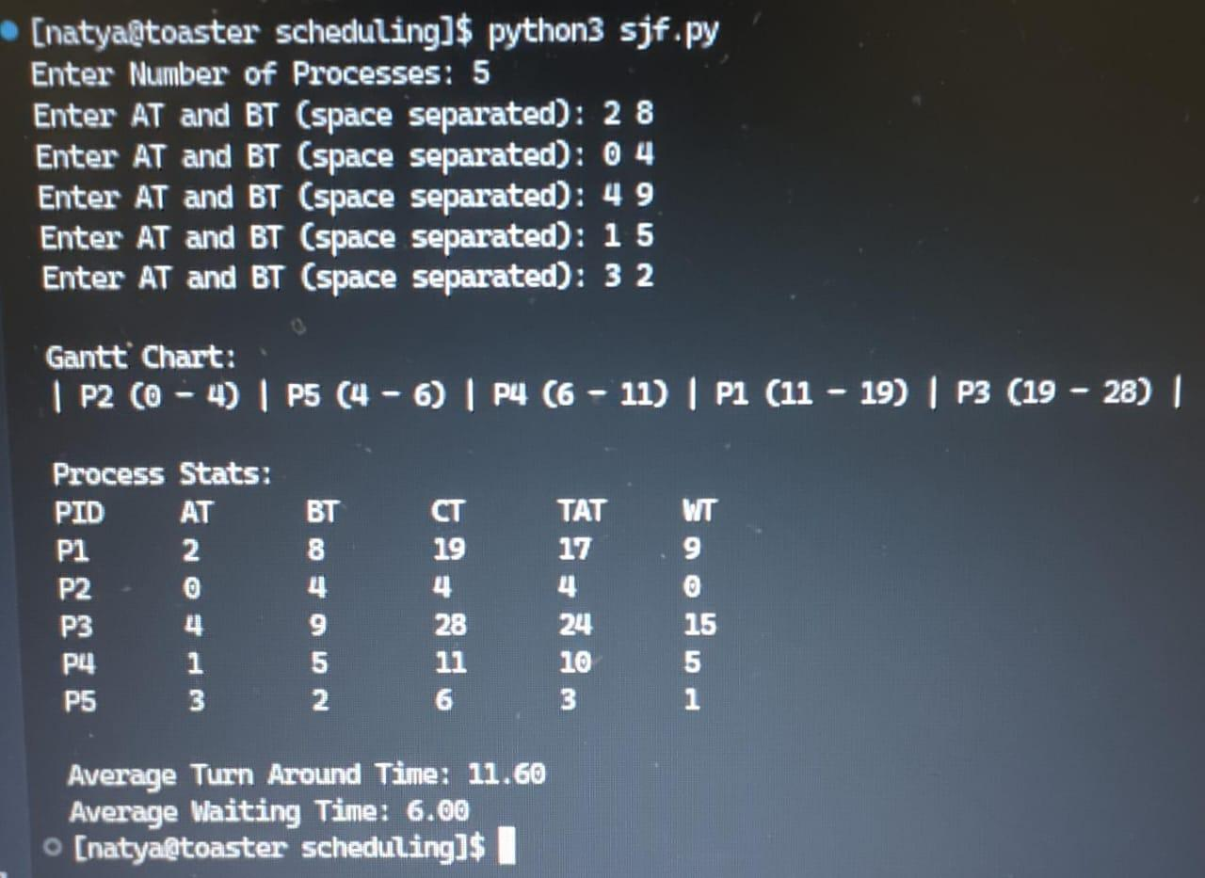

10. Priority Based
processes = []

n = int(input("Enter Number of Processes: "))
for i in range(n):
data = input(f"Enter AT and BT (space separated): ")
at, bt = map(int, data.split())
processes.append({"pid": i + 1, "arrival_time": at, "burst_time": bt})

queue = []
time = 0
completed = 0
gantt_chart = []
remaining_processes = processes.copy()
current_process = None
start_time = 0

while completed < n:
for process in list(remaining_processes):
if process["arrival_time"] <= time:
queue.append(process)
remaining_processes.remove(process)

if current_process is None and queue:
queue.sort(key=lambda x: x["burst_time"])
current_process = queue.pop(0)
start_time = time
current_process["remaining_time"] = current_process["burst_time"]

if current_process:
current_process["remaining_time"] -= 1

if current_process["remaining_time"] == 0:
end_time = time + 1
gantt_chart.append((current_process["pid"], start_time, end_time))
current_process = None
completed += 1

time += 1

print("\nGantt Chart:")
for pid, start, end in gantt_chart:
print(f"| P{pid} ({start} - {end}) ", end="")
print("|")

process_stats = {}
for pid, start, end in gantt_chart:
process_stats[pid] = {"completion_time": end}

for process in processes:
pid = process["pid"]
at = process["arrival_time"]
bt = process["burst_time"]
ct = process_stats[pid]["completion_time"]

tat = ct - at
wt = tat - bt

process_stats[pid].update({
"arrival_time": at,
"burst_time": bt,
"turn_around_time": tat,
"waiting_time": wt
})

print("\nProcess Stats:")
print("PID\tAT\tBT\tCT\tTAT\tWT")
total_tat = 0
total_wt = 0
for pid in sorted(process_stats.keys()):
stat = process_stats[pid]
at = stat["arrival_time"]
bt = stat["burst_time"]
ct = stat["completion_time"]
tat = stat["turn_around_time"]
wt = stat["waiting_time"]
total_tat += tat
total_wt += wt
print(f"P{pid}\t{at}\t{bt}\t{ct}\t{tat}\t{wt}")

print(f"\nAverage Turn Around Time: {total_tat/n:.2f}")
print(f"Average Waiting Time: {total_wt/n:.2f}")

Output
